MAIN –HOME PAGE



ABOUT US PAGE

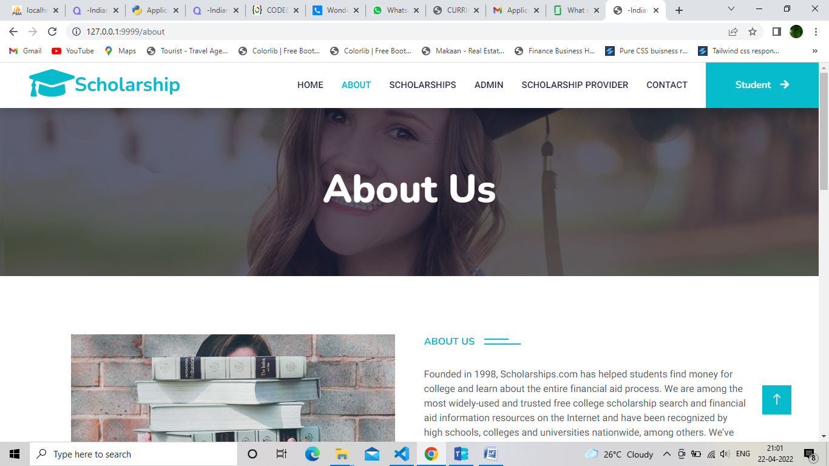

SCHOLARSHIPS

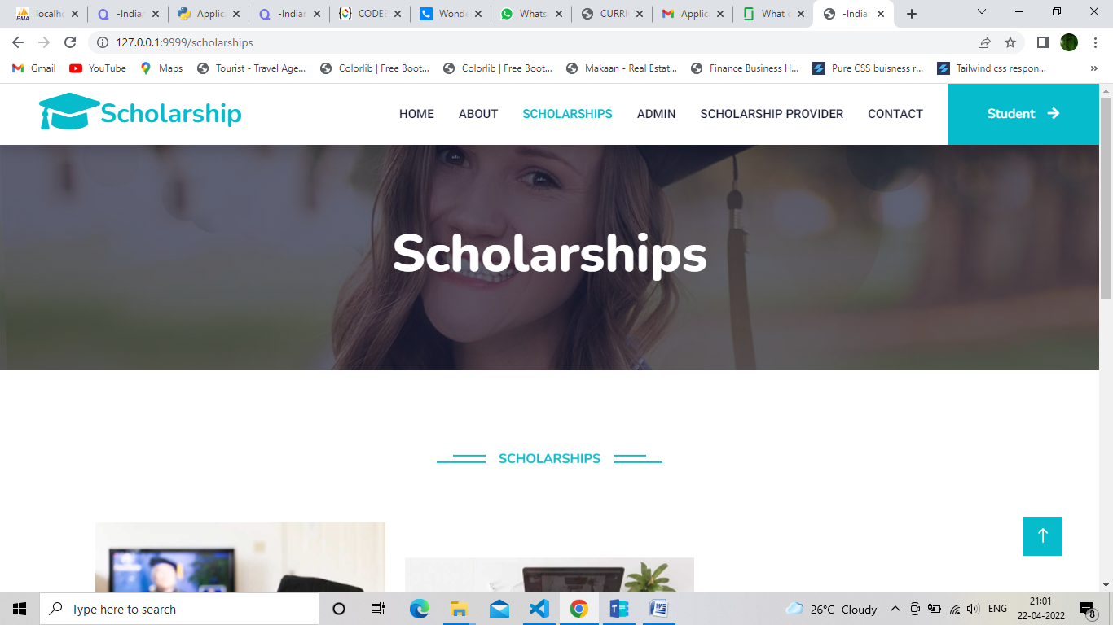

ADMIN-LOGIN

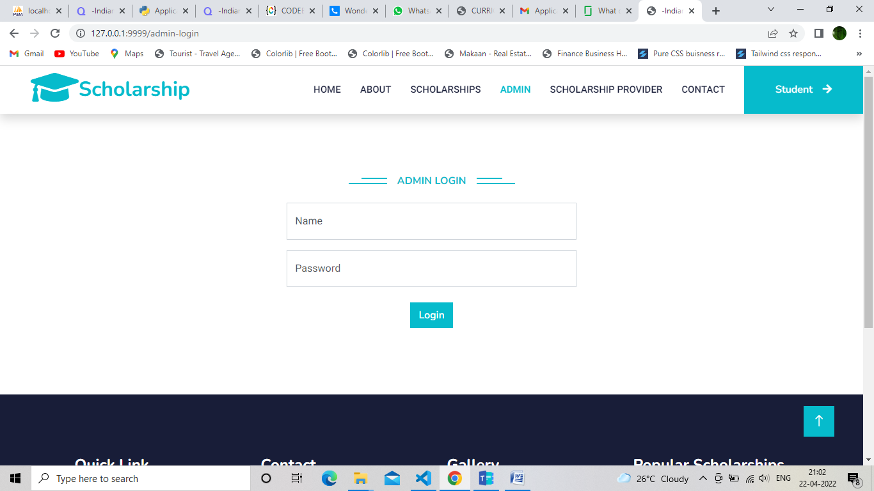

SCHOLARSHIP PROVIDER-LOGIN

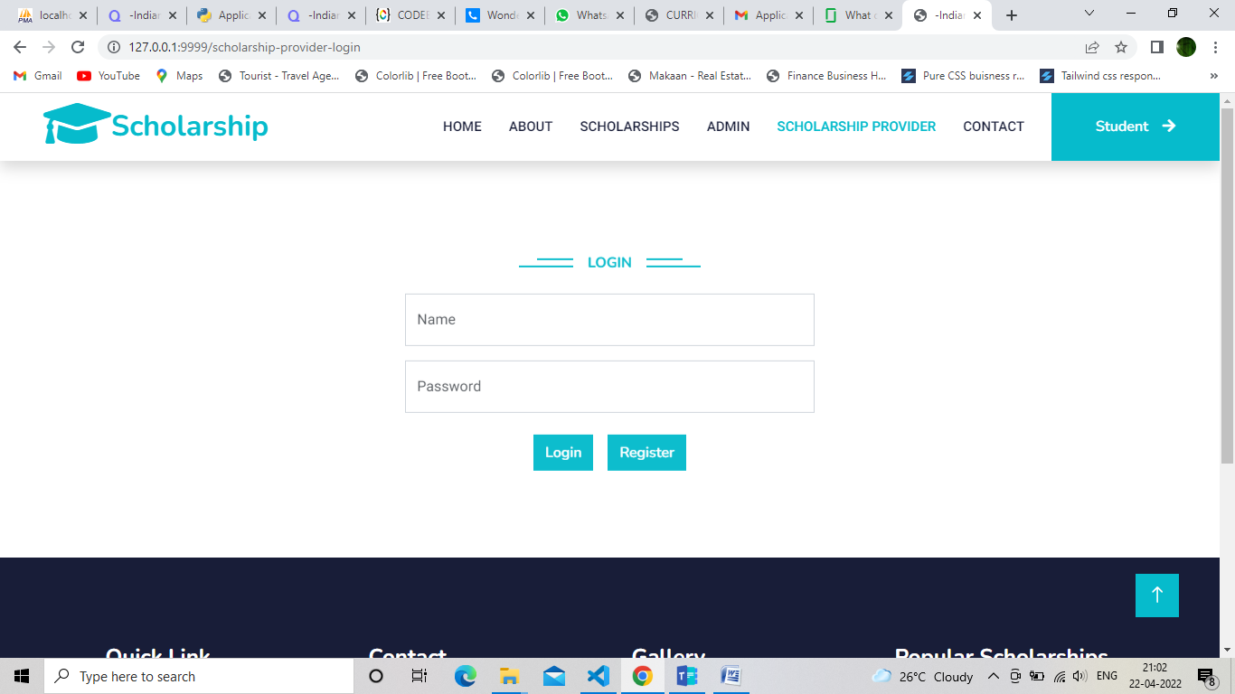

CONTACT

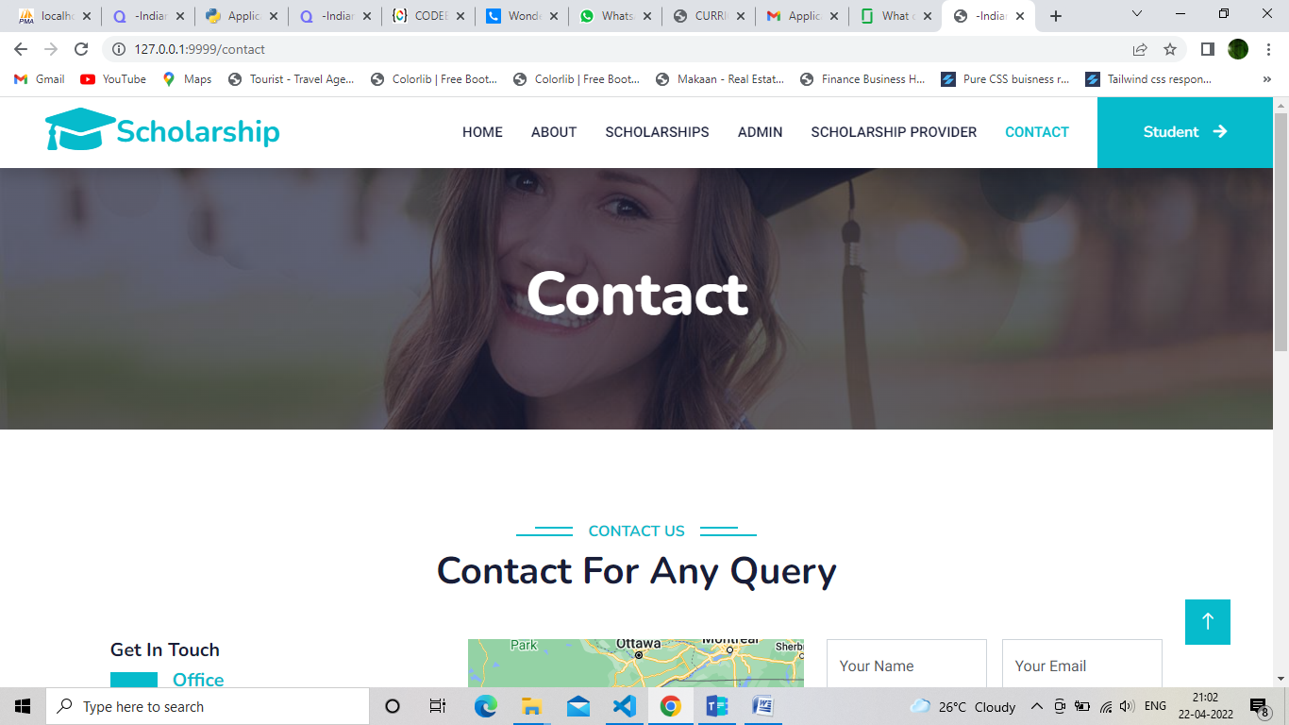

STUDENT-LOGIN

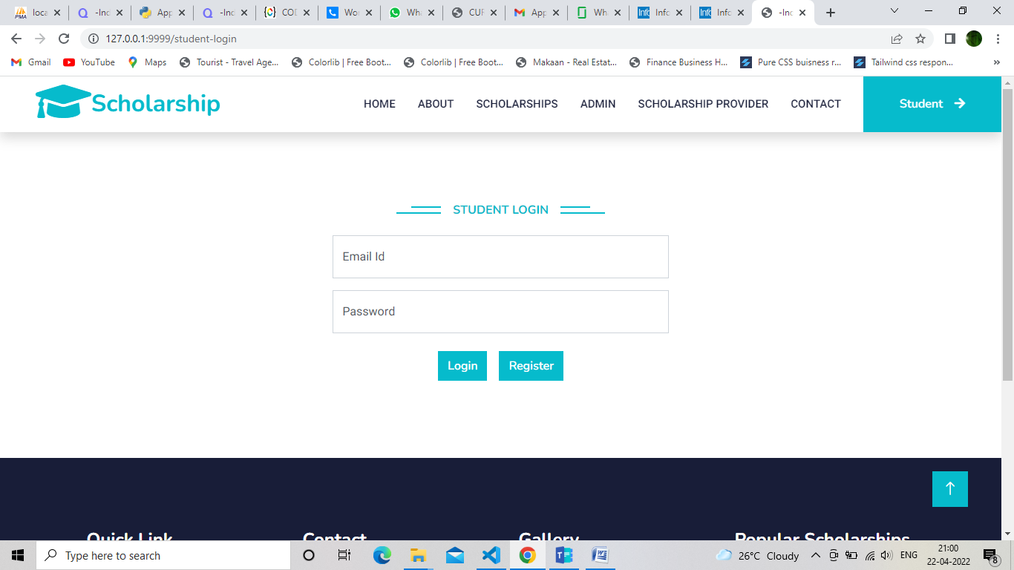

STUDENT HOME

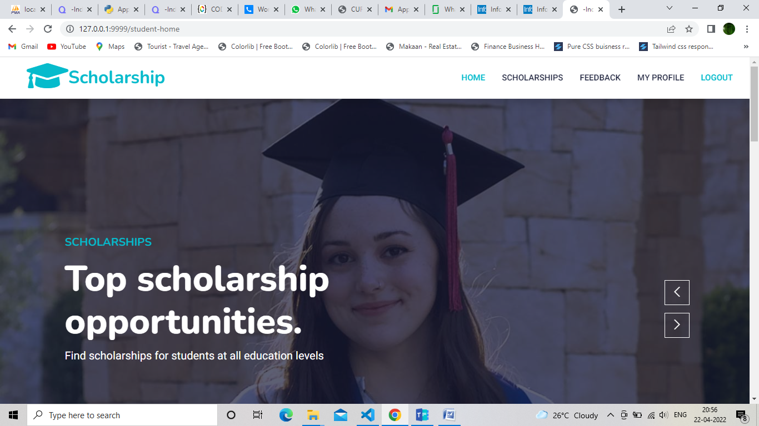

STUDENT/STUDENT SCHOLARSHIP

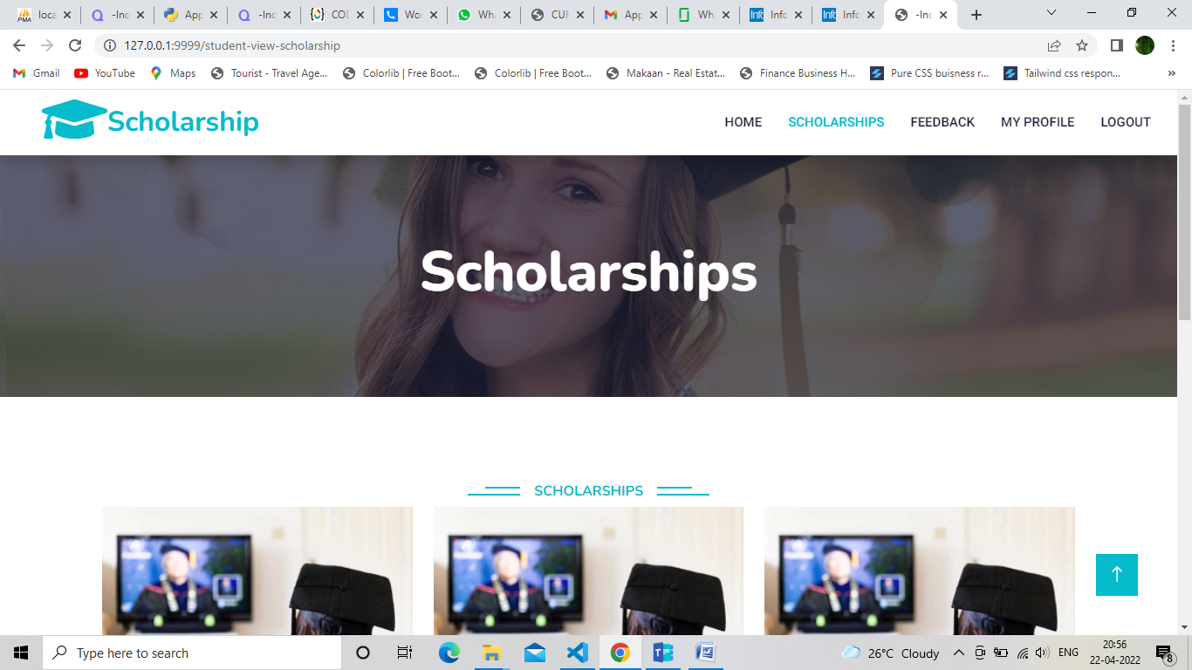

STUDENT/SCHOLARSHIP-DETAILS

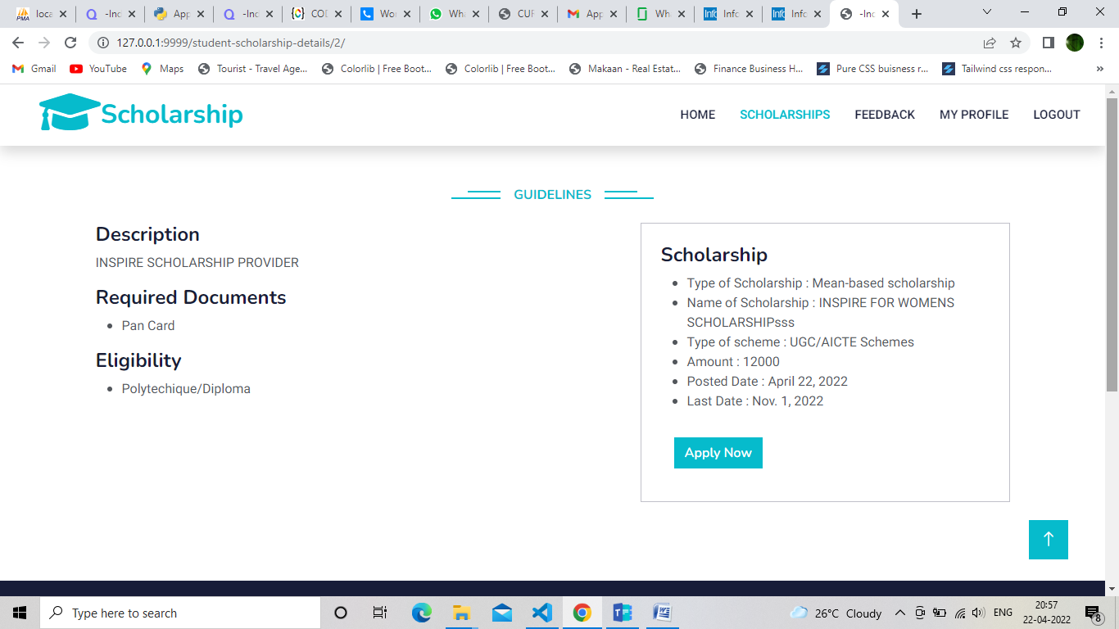

STUDENT/STUDENT-APPLICATION FORM

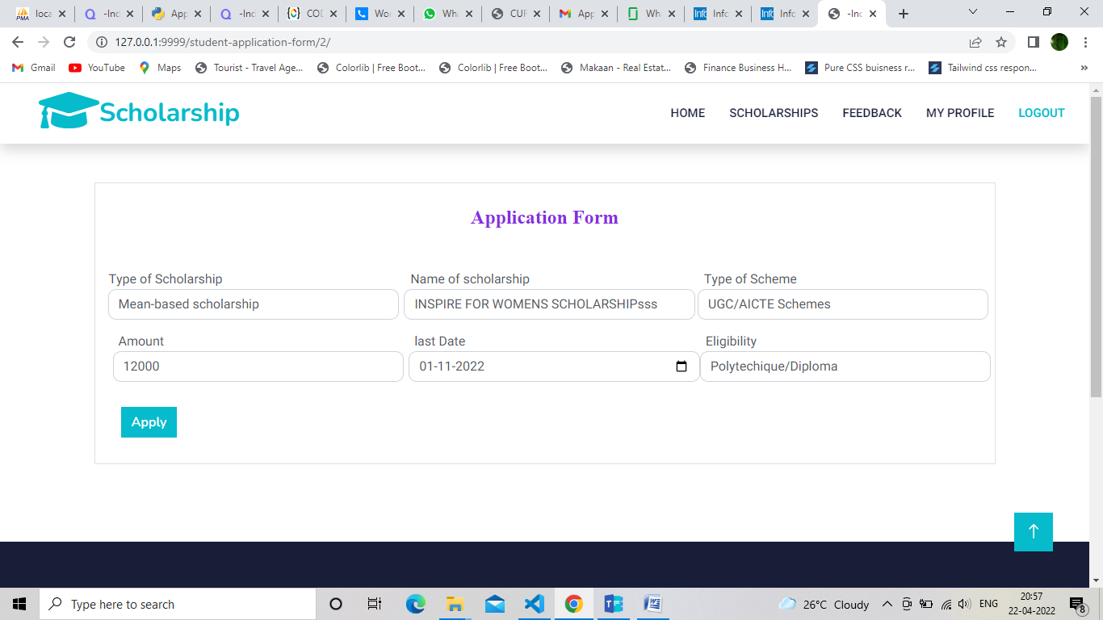

STUDENT/APPLIED DETAILS

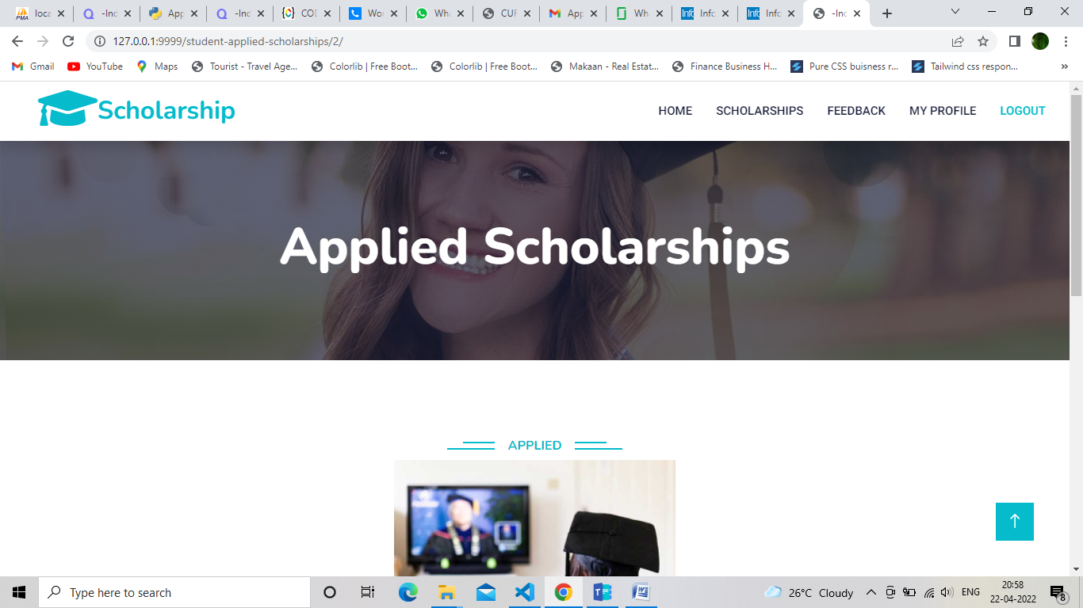

STUDENT/FEEDBACK

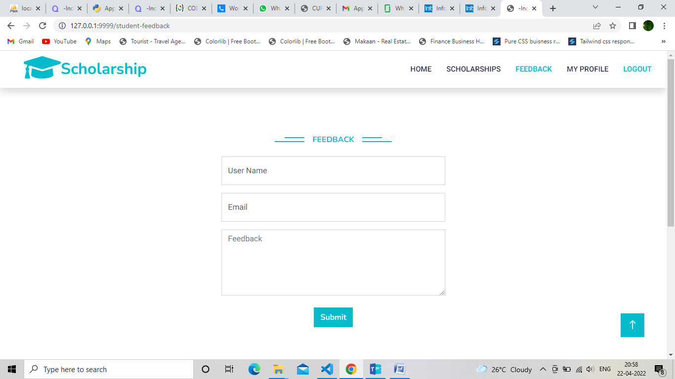

STUDENT/STUDENT-PROFILE

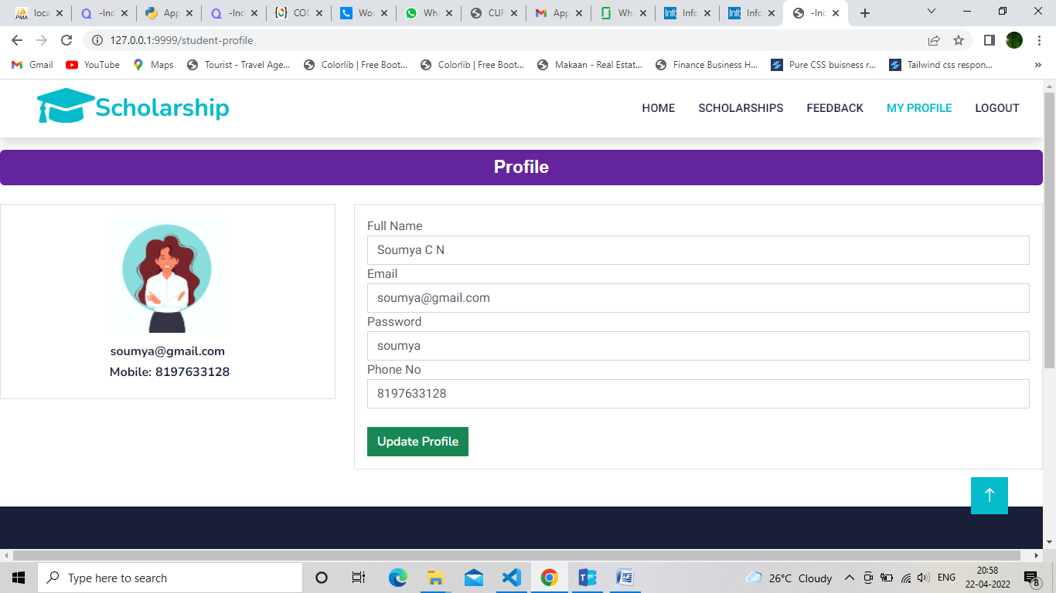

SCHOLARSHIP-HOME

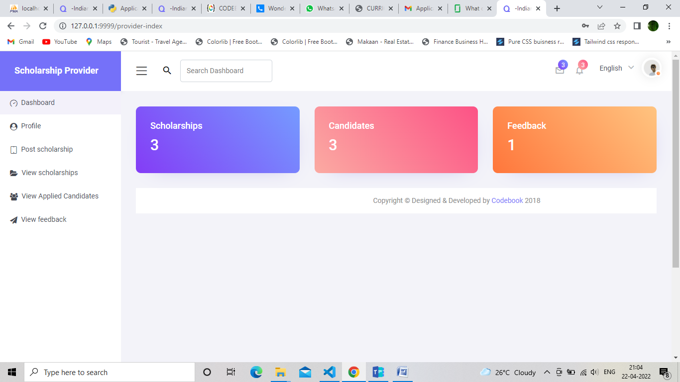

SCHOLARSHIP-PROFILE

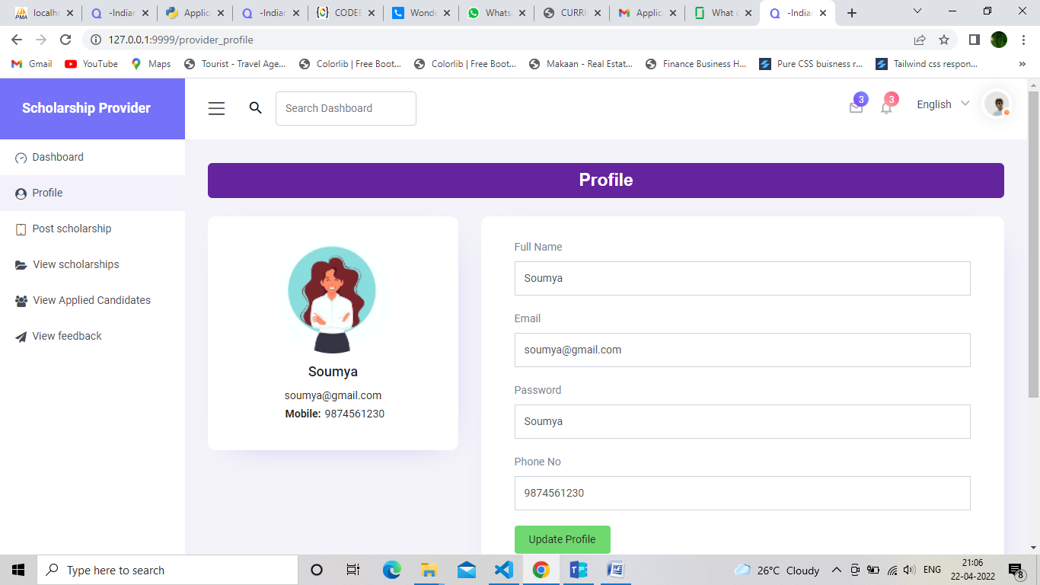

SCHOLARSHIP POST SCHOLARSHIP

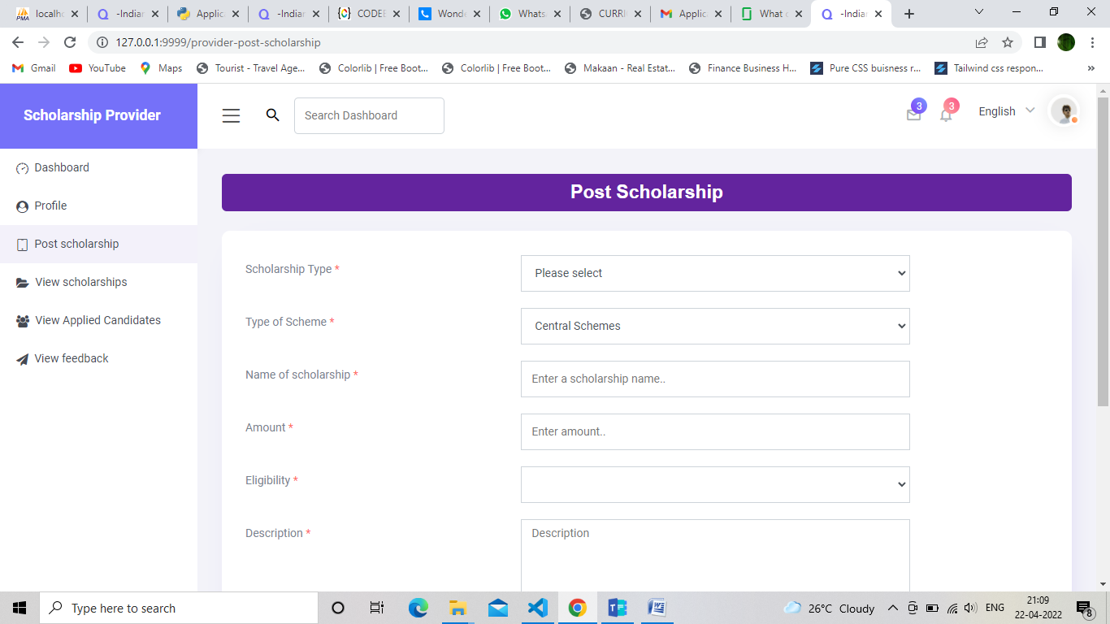

SCHOLARSHIP PROVIDER VIEW SCHOLARSHIP

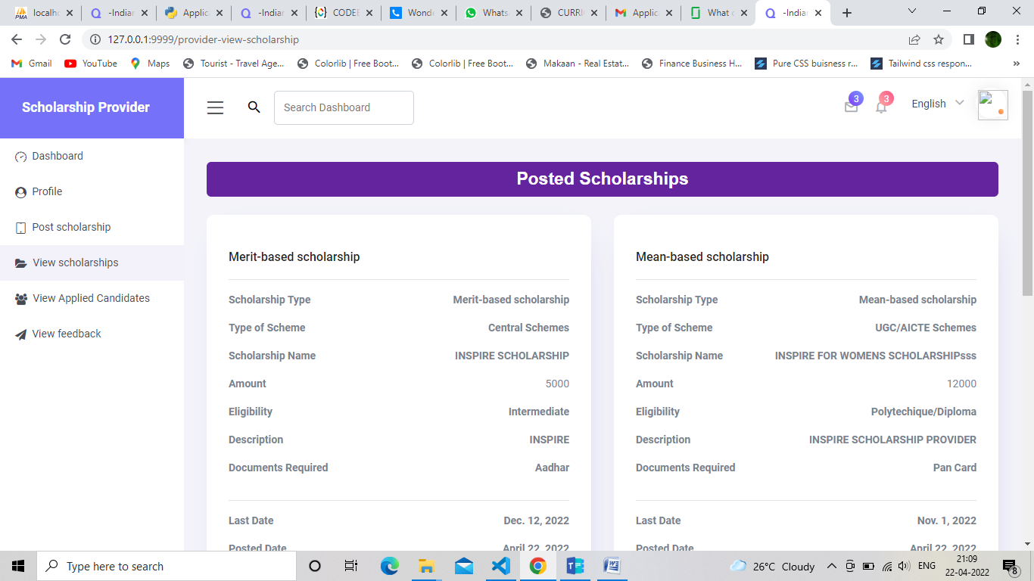

SCHOLARSHIP-VIEW APPLIED ACHOLARSHIPS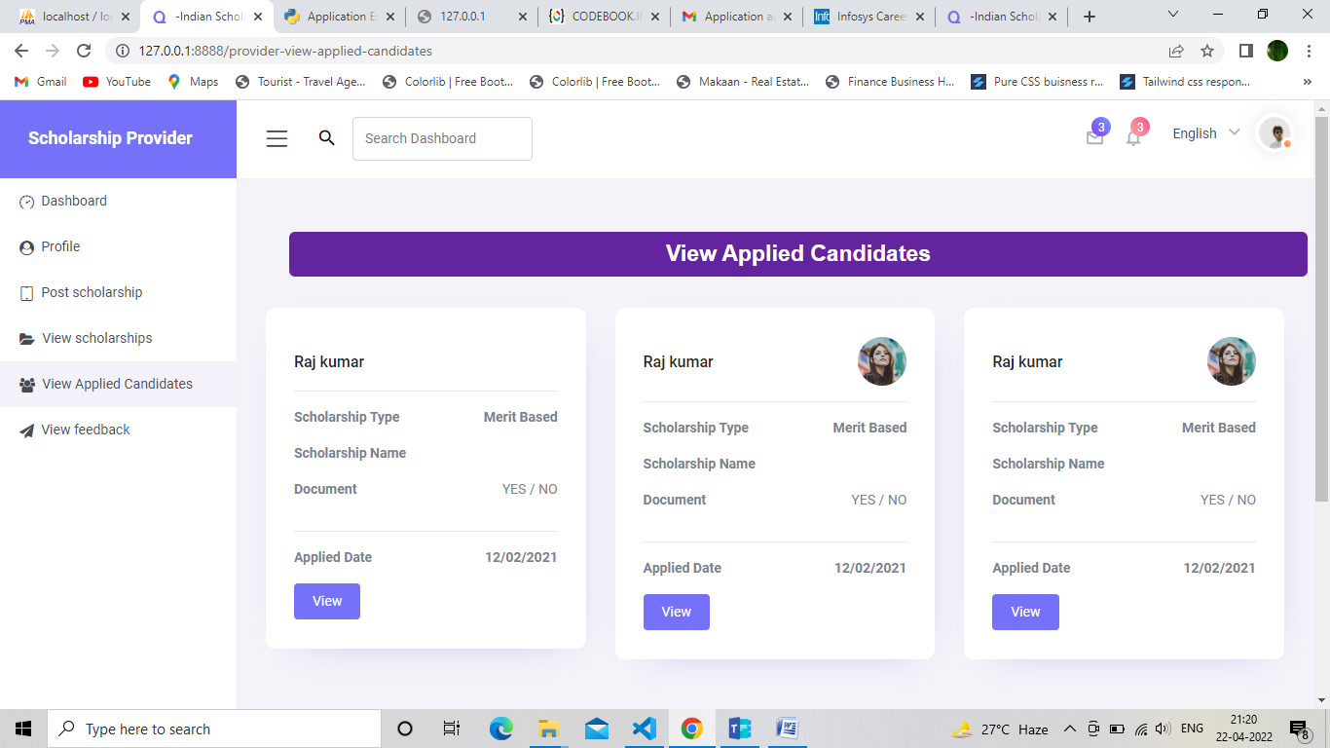

SCHOLARSHIP PRPOVIDERS FEEDBACK

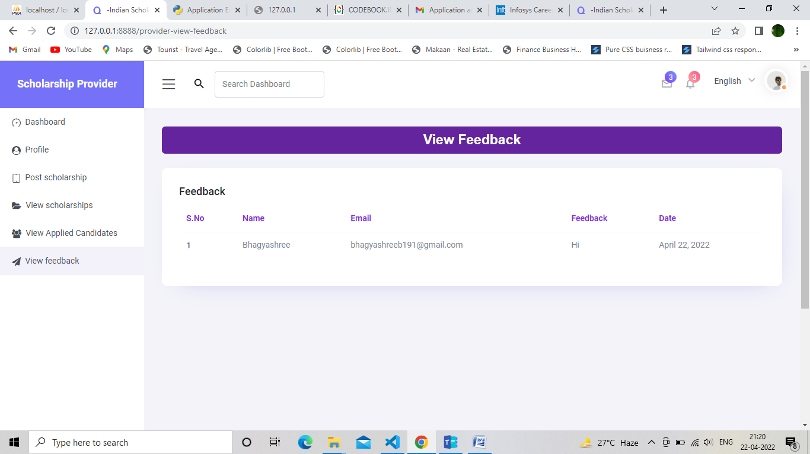

ADMIN-DASHBOARD

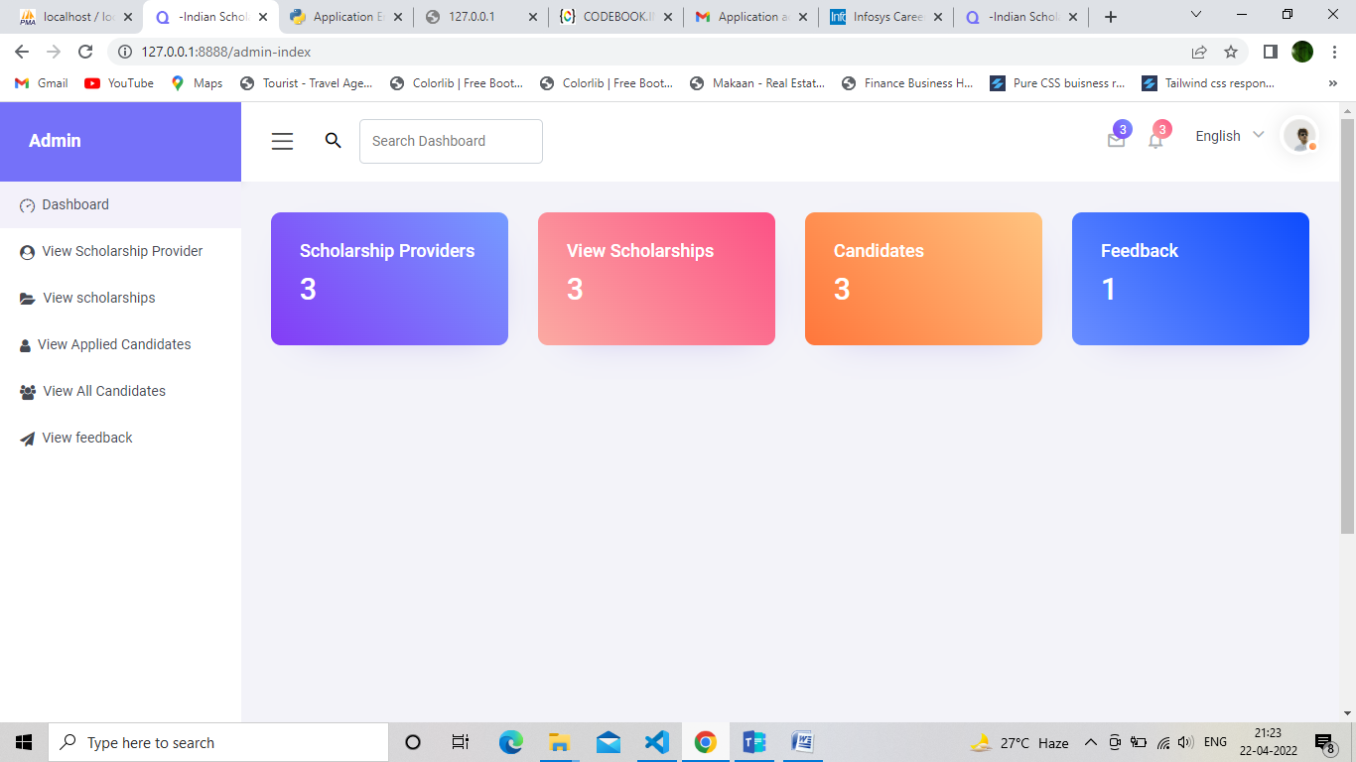

ADMIN-VIEW SCHOLARSHIP PROVIDER

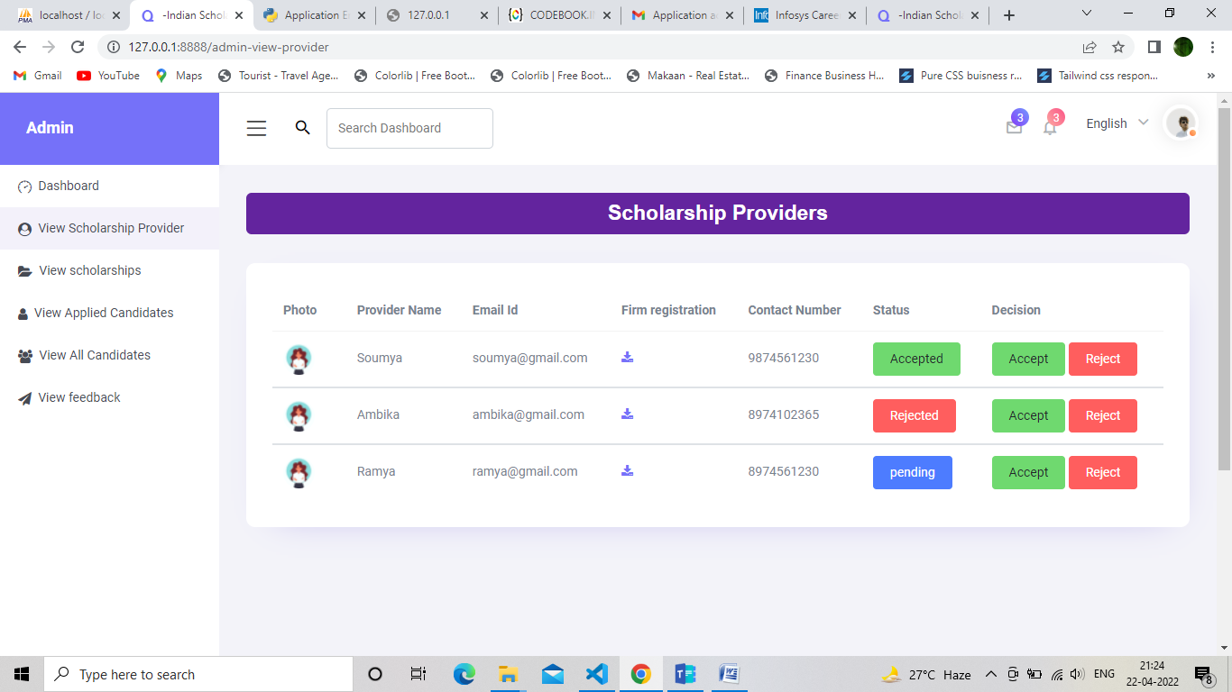

ADMIN-VIEW SCHOLARSHIP

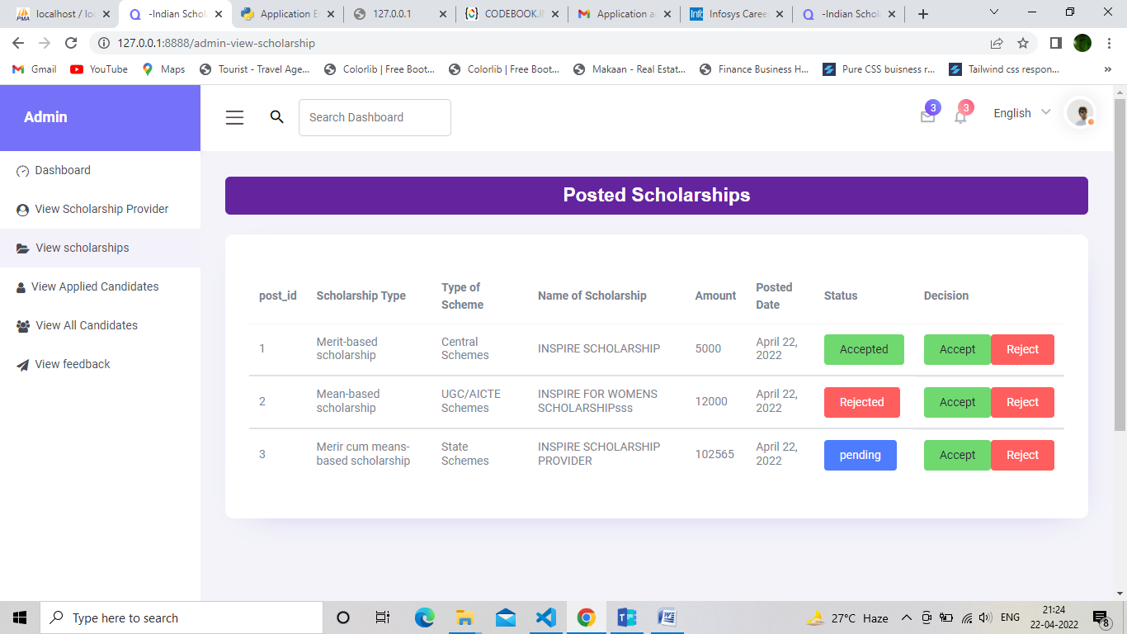

ADMIN/VIEW APPLIED CANDIDATES

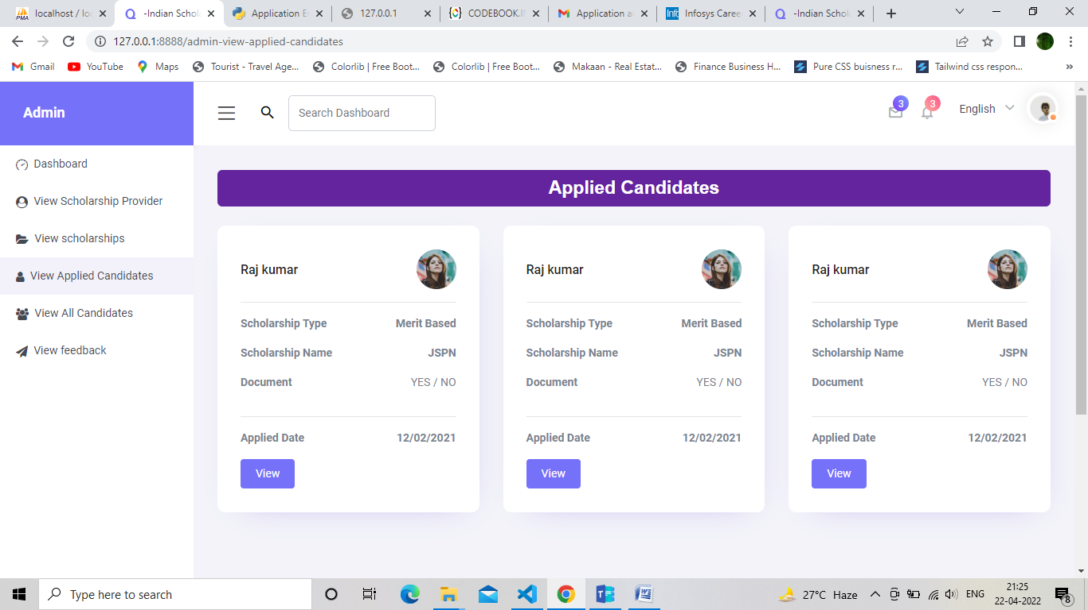

ADMIN/VIEW ALL CANDIDATES

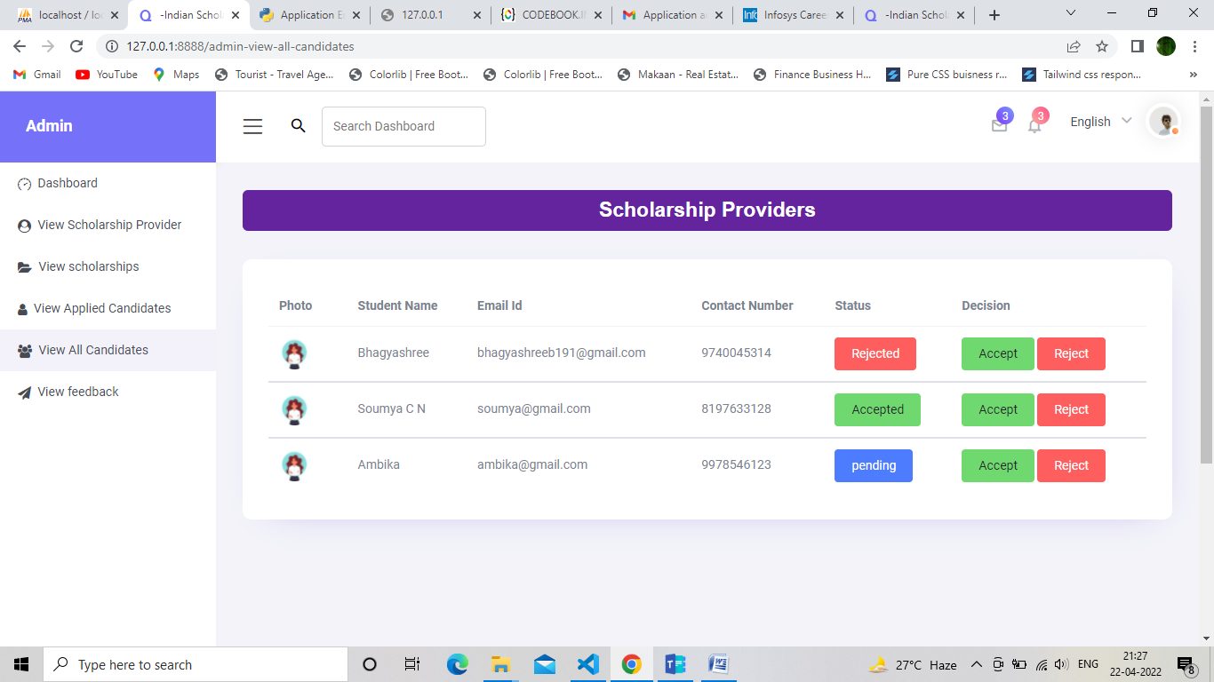

ADMIN/VIEW-FEEDBACK

